PhD VIVA VOCE
Candidate Name and Registration Number:  Proscovia Kemilembe Mujumba - 2010-07-00147 | 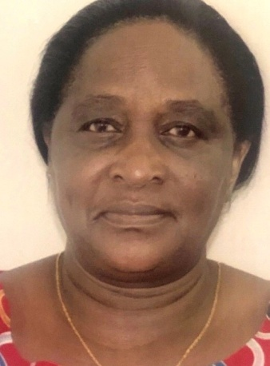  Proscovia Kemilembe Mujumba
Candidate Current Qualifications:
Master of Arts Education (1995)
Title of Dissertation/ Thesis:
“Effectiveness of Girls’ Education Interventions in Enhancing the Participation of Girls in Secondary Education in Bagamoyo District, Tanzania”
Date of Viva Voce: 28th January, 2020
Venue: SoED Board Room
Time: 10.00 a.m.

Panel Members:
No | Name | Designation | Rank | Unit
1 | Prof. E. Bhalalusesa | Chairperson | A/Professor | SoED-EFMLL
2 | Dr. J. Katabaro | Representing External Examiner | Lecturer | SoED-EPCS
3 | Dr. A. M. Sarakikya | Internal Examiner | Lecturer | SoED-EFMLL
4 | Dr. W. Maro | Head of the relevant Department (or his/her appointee) | Lecturer | SoED-EPCS
5 | Dr. A. Tarmo | Co-opted Member (appointed by College/School/Institute | Lecturer | SoED-EPCS
6 | Dr. B. Kanukisya | Co-opted Member (appointed by College/School/Institute | S/Lecturer | SoED-EFMLL
7 | Dr. L. Mahai | Co-opted Member(for PhD only) | Lecturer | SoED-EFMLL
8. | Dr. R. Mwaipopo | Appointee of the Principal (for PhD only) | S/Lecturer | CoSS

Supervisor:
1. | Prof. M.K. Possi | Candidate’s Supervisor | A/Professor | SoED-EPCS

Abstract:
This study investigated the effectiveness of girls’ education interventions (GEIs) in enhancing the participation of girls in secondary education in Bagamoyo district in Tanzania. It was guided by interpretive research paradigm and employed qualitative research approach using interviews, focused group discussions, documentary reviews and observations as data collection methods. Data was analysed thematically using four components of CIPP adapted from Stufflebeams (2000) as a conceptual framework. The components were context, inputs, process and product of CAMFED GEIs. The study purposively involved 60 participants selected by virtue of their positions and from categories of boarding and day sampled schools. These included: 4 heads of schools, 16 teachers; 16 Bursary Beneficiary Girls (BBGs), 8 BBGs’ parents, 3 Board Members, 4 Ward Education Coordinators, 4 Village Chair Persons, 2 Ministry of Education Science and Technology officials,1 Secondary District Education Officer and 2 CAMFED-TZ personnel. The findings revealed that stakeholders recognised the importance of girls’ education, therefore considered CAMFED GEIs to be significant since they tackled some barriers to girls’ education. Identified CAMFED–TZs’ strengths included: availability of funds; identification of needy girls and their barriers and providing them with the necessary support. Further, the findings revealed that, the involvement of key stakeholders in GEIs activities was poor, hence affected enhancement of retention; completion rates and academic performance of BBGs. Major Challenges to GEIs were: poor retention; completion rates and academic performance of BBGs as well as poor community attitudes towards education, hence resulting into ineffectiveness of GEIs to stakeholders. However, five impacts were revealed including; improved access, retention and academic performance of girls in boarding schools, change of parents’ attitudes towards girls’ education as well as orienting BBGs to join CAMA groups and facilitate their eligibility for financial support from CAMFED-TZ to start small businesses and become self reliant. The study concludes that CAMFED GEIs have not been very effective, due to lack of involvement of key stakeholders into the programme. The study recommends the following: focused GEIs aimed at achieving broader goals of girls’ education; necessity for sensitization and collaborative efforts with stakeholders and teachers to be recognised as key stakeholders, obliged to provide assistance to poor performing BBGs; each BBG to be attached to her own Teacher Mentor to enable close monitoring and assistance; BBGs and their parents to abide by the programme regulations; vulnerable girls to be placed in quality boarding schools to enhance their retention and performance and upon their graduation to be assisted to get employment and communities to start Community Education Fund for programme sustainability. This study contributes to an understanding of the necessity of involving key stakeholders in all stages of GEI activities so as to enhance the participation of girls in secondary education in Tanzania.

